31) Syntax:

usermod [options] USER

32) Syntax:
groupadd [option] group_name
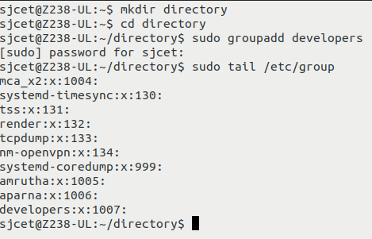

33) Syntax:

groups [username]...
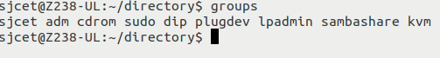

34) Syntax:

groupdel [options] GROUP
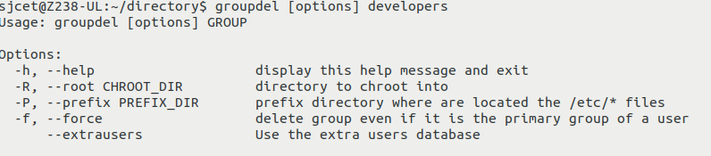

35) Syntax:

groupmod [option] GROUP
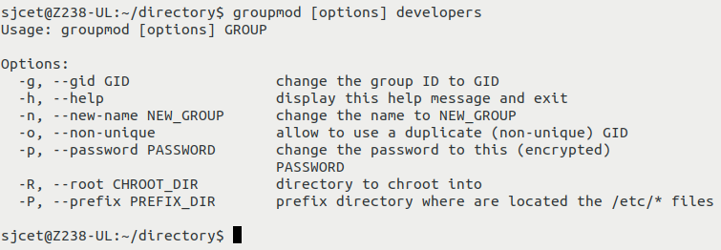
36) Syntax :

chmod [reference][operator][mode] file...

37)Syntax:

chown [OPTION]… [OWNER][:[GROUP]] FILE…
chown [OPTION]… –reference=RFILE FILE…
38) id [OPTION]… [USER]
39) Syntax:
ps [options]

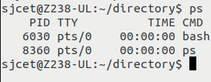

40) Syntax:

top [options]

